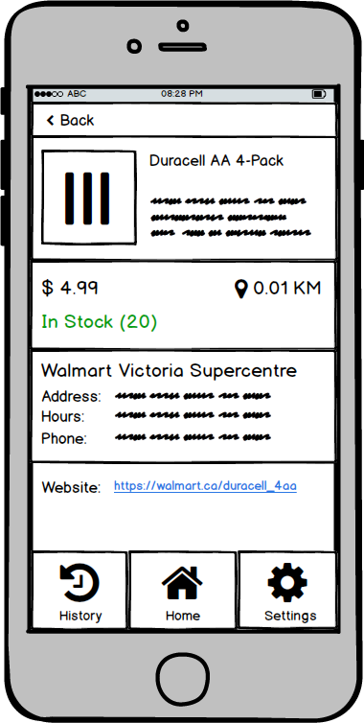

S 4ad In Stock (20)

**Walmart Victoria Supercentre**

**AddreSS. MMMMM MMMM MMMMMs Mars MMs**

Hours: SSLLSLSSSLS SLSLSLSLSL LSSLSLSSLSLSS SSLSLSL LSSSSLLLSSL

**Phone.**

Website. https://walmartical duracell 400